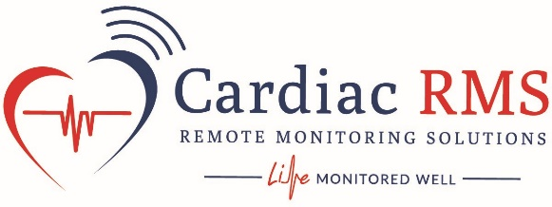

Territory Sales Consultant
Multiple City/States
Cardiac RMS, LLC. (“CRMS”) is an innovator in digital health and remote patient monitoring, with a focus on providing the most diagnostically-accurate, clinically and economically effective remote cardiac device patient management support and comprehensive remote care management in the industry. CRMS is an award winning, Medicare approved Independent Diagnostic Testing Facility, provider of remote patient monitoring services. CRMS utilizes an industry leading, FDA Approved, cloud-based patient management system and device data diagnostic reporting platform. CRMS Management and Clinical Staff are Cardiac Rhythm Management and Remote Patient Monitoring industry veterans and IBHRE certified cardiac device specialists.
Description of Sales Contract
Cardiac RMS is looking to contract with industry veterans who have an entrepreneurial spirit and are dedicated to making a difference in advancing implantable cardiac device patient care and comprehensive remote care management. Currently, we are looking for Territory Sales Consultants who have experience in Cardiac Rhythm Management device sales and or disease specific patient monitoring services, who will contract with the company to raise awareness about CRMS’s innovative Care Management Programs and drive market adoption of Remote Device Patient Outsourced Monitoring and Remote Care Management as the new standard of care in remote patient follow-up. CRMS is looking to contract with proven individuals and companies that have a combination of implantable medical device territory sales experience (ideally with a focus on Cardiology or EP) and remote monitoring services territory sales management.
Responsibilities Under the Sales Contract
• Generate Clinical Service Referrals!
• Leverage current relationships and network with Electrophysiologists, Cardiologists, and other disease specific specialties to develop opportunities to introduce and promote CRMS technologies & patient services.
• Use CRMS marketing materials and personal industry knowledge and experience to promote, educate and refer new business.
• Educate physicians, office staff, hospital administration on best practices for remote device patient care and CRMS services advantages.
• Identify key decision makers, schedule CRMS introduction discussions, technology demos.
• Communicate Clinic Service leads to CRMS’s business Development Team.
• Work with CRMS’s Business development team as necessary on services proposal development, negotiation, and closure. Required Experience, Qualifications, Skills
• Proven track record of successful medical sales
• Cardiac Rhythm Management (CRM) Sales Associates or Clinical Sales Reps (from implantable pacemaker and defibrillator or ablation therapy companies such as Medtronic, Boston Scientific, St. Jude Medical, Abbott, and Biotronik) that are seeking their own territories highly preferred
• Experience in Cardiology or Electrophysiology Sales, Medical Device Sales, Diagnostic Services Sales, Cardiac Monitoring Sales, and/or other remote patient monitoring sales experience preferred
• Demonstrated, active territory network and clinic relationships
• Excellent written and verbal communication skills
• Ability to travel within assigned territory as needed

